Phase 5 project

Project tittle: - Fake news detection using NLP

Problem definition: The problem is to develop a fake news detection model using a Kaggle dataset. The goal is to distinguish between genuine and fake news articles based on their titles and text. This project involves using natural language processing (NLP) techniques to preprocess the text data, building a machine learning model for classification, and evaluating the model's performance.

Phase 1: Problem definition and Design Thinking

DATA COLLECTION:

1.Define Your Objectives: Clearly define the objectives of your fake news detection project. Determine the types of fake news you want to detect (e.g., misinformation, disinformation, satire) and the scope of your project (e.g., social media, news articles, user-generated content).

2.Data Sources: Identify reliable sources for collecting data. Some potential sources include: News websites and archives social media platforms (Twitter, Facebook, Reddit) Fact-checking websites (Snopes, FactCheck.org) Crowdsourced datasets (e.g., labelled data from reputable organizations)

3.Data Collection Methods: Depending on your objectives, you can use various methods to collect data, including web scraping, APIs, and manual data entry. Consider using a combination of these methods to obtain a diverse dataset.

4.Data Selection and Sampling: Select a representative sample of data that covers the range of fake news types and topics you want to detect. Ensure that your dataset is balanced, meaning it contains both fake and legitimate news articles in appropriate proportions.

DATA PROCESSING:

1.Data Cleaning: Remove any irrelevant or redundant information from the dataset. Handle missing data by imputing or removing incomplete records. Eliminate formatting inconsistencies, such as special characters and HTML tags.

2.Text Preprocessing: Tokenization: Split the text into individual words or tokens. Stop word Removal: Remove common words (e.g., "and," "the") that do not provide much information for fake news detection. Lowercasing: Convert all text to lowercase to ensure consistency. Stemming or Lemmatization: Reduce words to their root form (e.g., "running" to "run") to improve feature extraction and reduce dimensionality. Spell Checking: Correct common spelling errors to improve the quality of the text data.

3.Feature Extraction: Convert the processed text into numerical features that machine learning models can use. Common techniques include: Bag of Words (Bow): Create a vector of word frequencies. Term Frequency-Inverse Document Frequency (TF-IDF): Weight words by their importance in a document relative to the entire dataset. Word Embeddings (e.g., Word2Vec, Glove): Represent words as dense vectors. Character-level features: Consider character-level n-grams for capturing specific patterns.

EXPLORATORY DATA ANALYSIS:

1. Data Loading: Load your dataset into a data analysis environment such as Python with libraries like pandas and NumPy or R.

2.Basic Data Inspection: Begin by looking at the first few rows of your dataset to understand its structure and format. Check the data types of columns and identify any missing values. 3.Descriptive Statistics: Calculate basic statistics for numerical features, such as mean, median, standard deviation, and range. For categorical features, calculate frequency counts and percentages. 4.Data Visualization: Create visualizations to gain insights into the data. Common types of plots and graphs include: Histograms and density plots to visualize the distribution of numerical features. Bar charts to visualize the distribution of categorical features. Box plots for identifying outliers. Scatter plots or pair plots for exploring relationships between variables. Word clouds or bar charts to visualize the most frequent words in text data.

PREDICTIVE MODELING:

1.Splitting the data: Split the dataset into training, validation, and test sets. The training set is used to train the model, the validation set for hyperparameter tuning, and the test set to evaluate the final model's performance.

2.Feature Selection: Choose the most relevant features for your predictive model. Feature selection techniques like mutual information, feature importance from tree-based models, or domain knowledge can help identify the most informative features.

3.Model Training: Train the selected model on the training data. Experiment with different hyperparameters to find the best model configuration. Use appropriate evaluation metrics (e.g., accuracy, precision, recall, F1-score) to monitor the model's performance on the validation set during training.

4.Model Evaluation: Evaluate the final model's performance on the test dataset to assess its ability to detect fake news accurately. Consider using additional metrics like ROC AUC (Receiver Operating Characteristic Area Under the Curve) if applicable.

TOOLS:

•Scikit-Learn (Python)

•python

•NLTK (Natural Language Toolkit)

•VADER (Python)

•TensorFlow

•Matplotlib, Seaborn (Python)

•GitHub or GitLab TECHNOLOGIES:

•Natural Language Processing (NLP)

•Text Classification Algorithms

•Data Mining and Information Retrieve

•Named Entity Recognition (NER)

•Machine Learning Libraries

•Version Control Systems

Phase 2: Inovation

INNOVATIVE IDEAS ON FAKE NEWS DETECTION WITH NLP:-

Real-Time Monitoring:

Create a system that continuously monitors news sources and alerts users to potentially fake news in real-time. This could involve web scraping, social media analysis, and text classification.

Ethical Considerations:

Consider the ethical implications of your model. How will it be used, and what safeguards can be put in place to prevent misuse

Human-AI Collaboration:

Investigate how humans and AI can work together to improve fake news detection. This may involve a human-in-the-loop system where human experts review and validate model predictions

Multimodal Approach:

In addition to analysing text, include other modalities like images and audio if your dataset contains them. Combining information from multiple sources can enhance the accuracy of fake news detection.

User Feedback Loop:

Develop a user interface that allows users to report suspicious news articles, and use this feedback to continually improve your model.

Transfer Learning:

Explore pre-trained language models, like GPT-3 or BERT, and fine-tune them on your fake news detection task. These models have shown remarkable performance in various NLP tasks.

Deep Reinforcement Learning:

Implement reinforcement learning techniques to create an agent that learns to identify fake news through interactions with a simulated news environment. This could help the model adapt to evolving news sources and tactics.

Visualization Tools:

Develop interactive visualization tools to help users better understand the credibility of news sources and articles.

Phase 3: Project Development Part 1

Importing libraries and reading data set:

o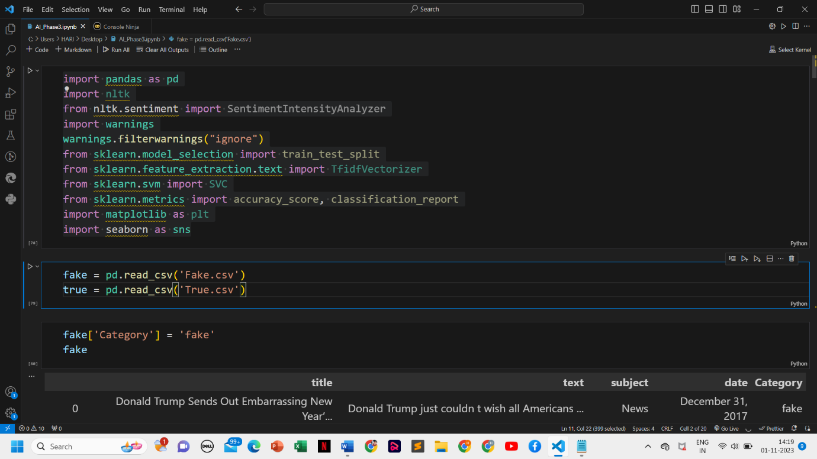

category checking:



Detecting fake news:



Data category:

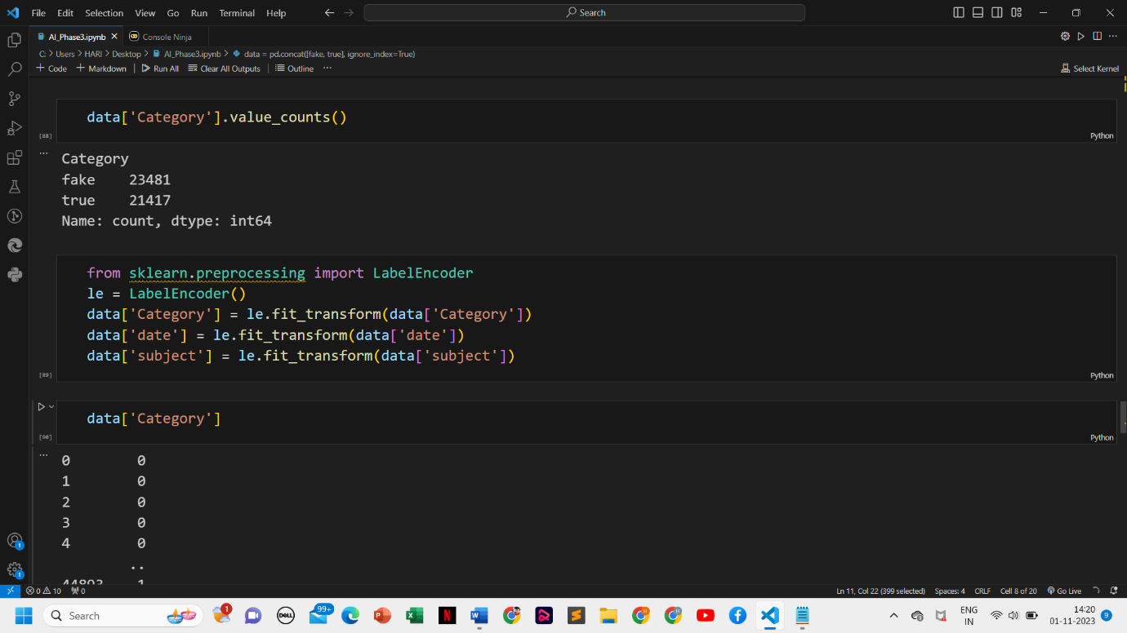

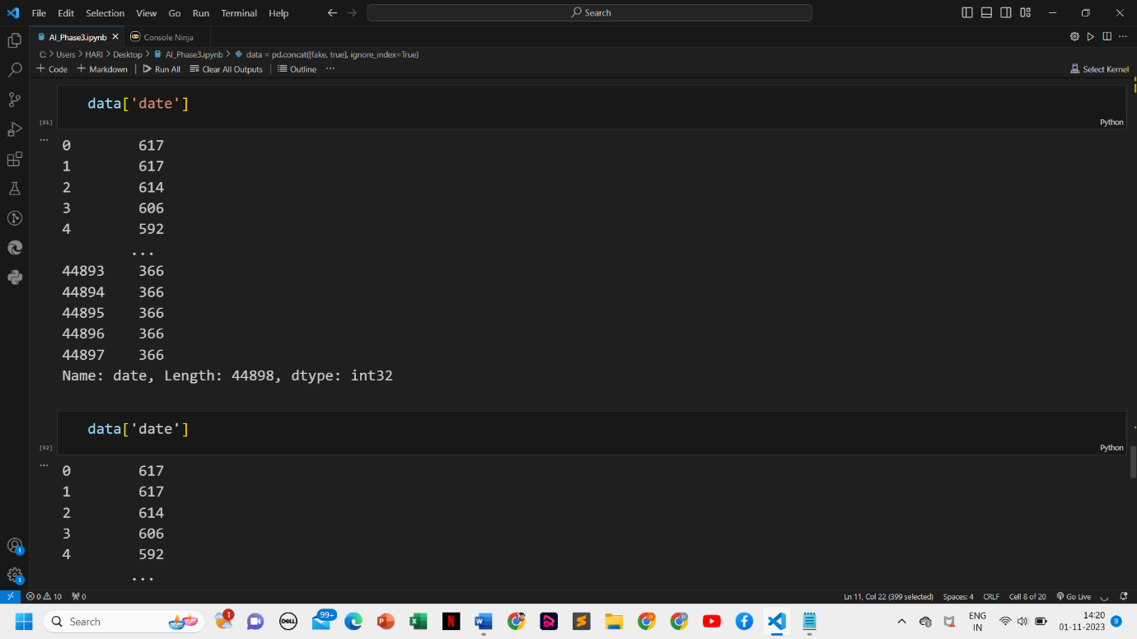

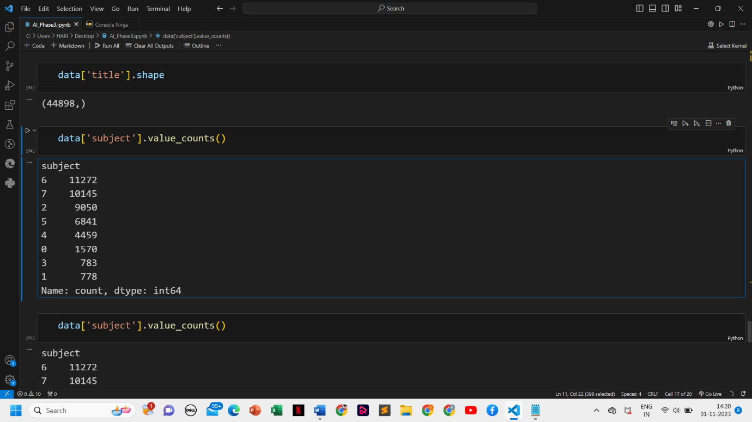

Plotting: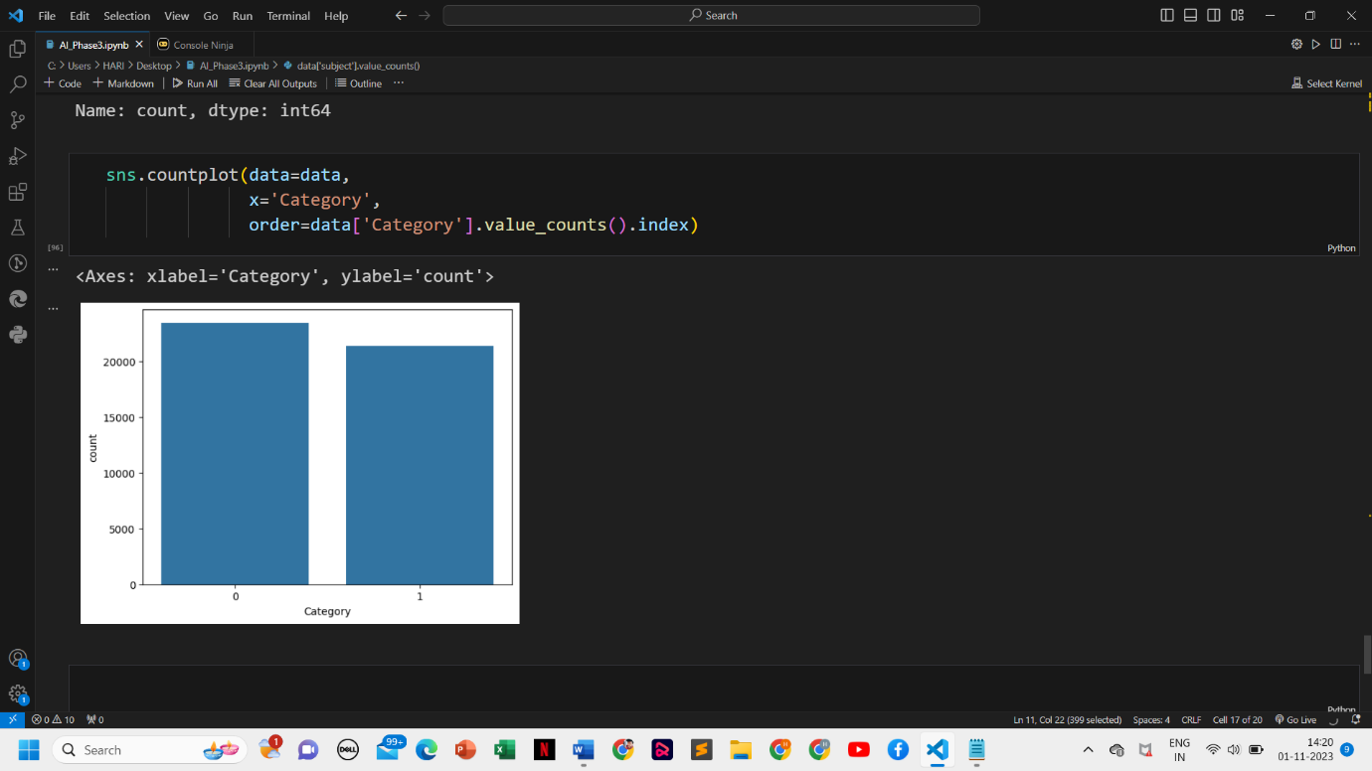

Phase 4: Project development part 2

In phase 4 also as done in phase 3 we import libraries and reading data set.

In development part 1 we did the following steps

The step 1 is to detecting the categories of the data.

The step 2 is to detecting the fake news.

The step 3 is analysing data category of the data.

The last step 4 plotting the data.

Now we are doing the development past 2

Preprocessing and analysis of News column:

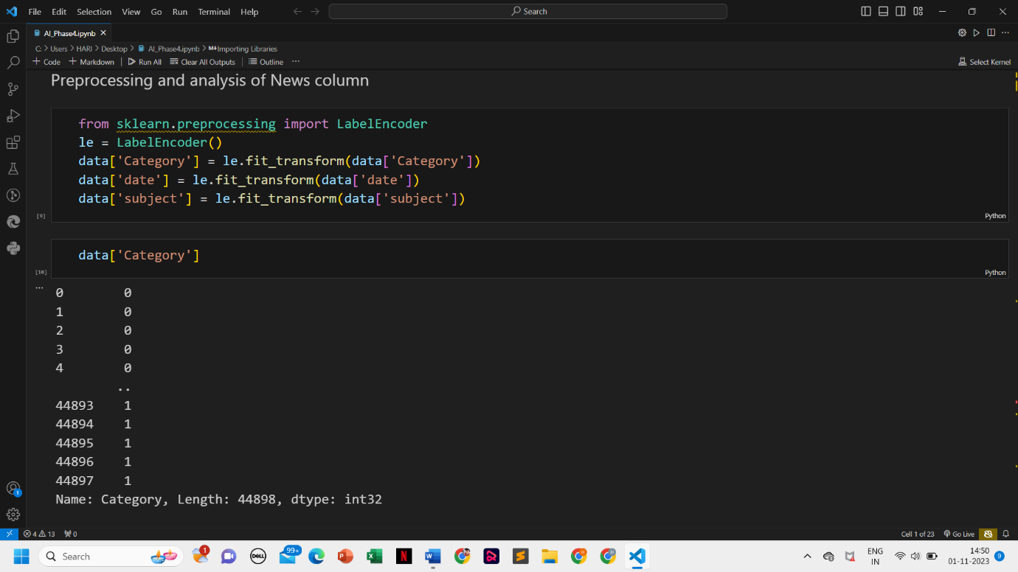

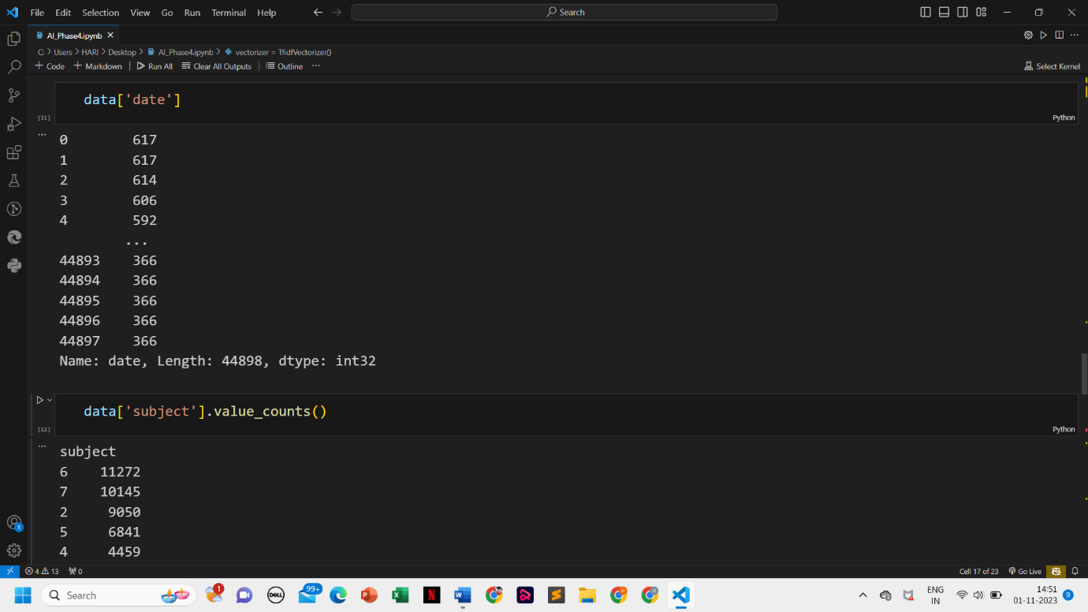

Model training, Evaluation, and prediction: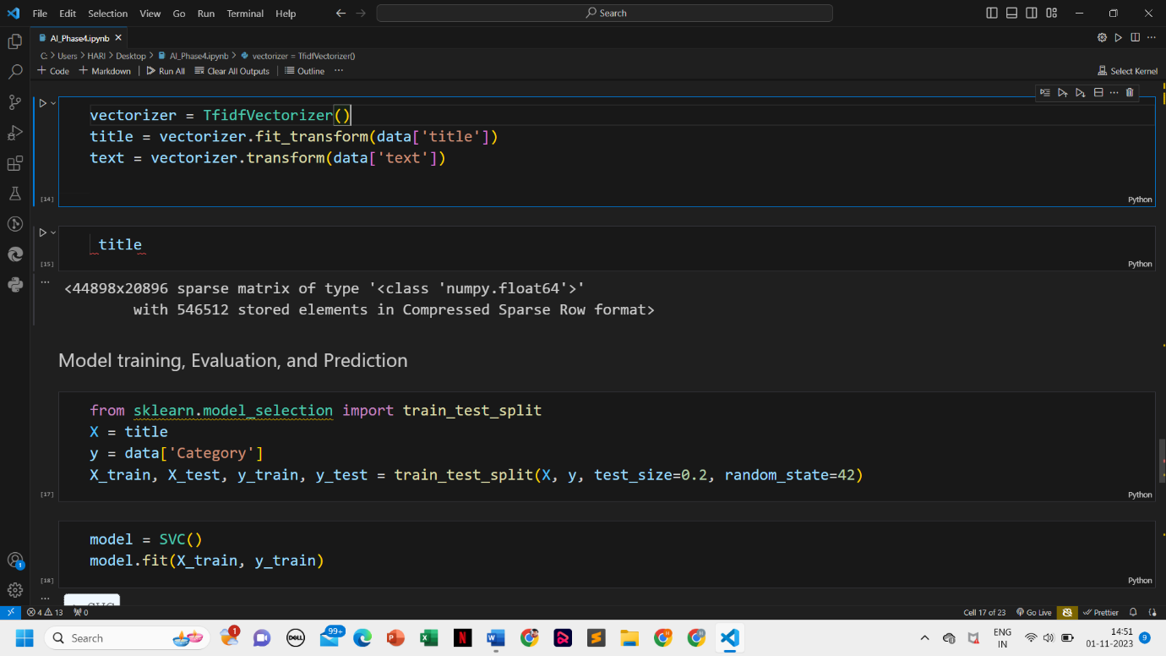

Checking accuracy:

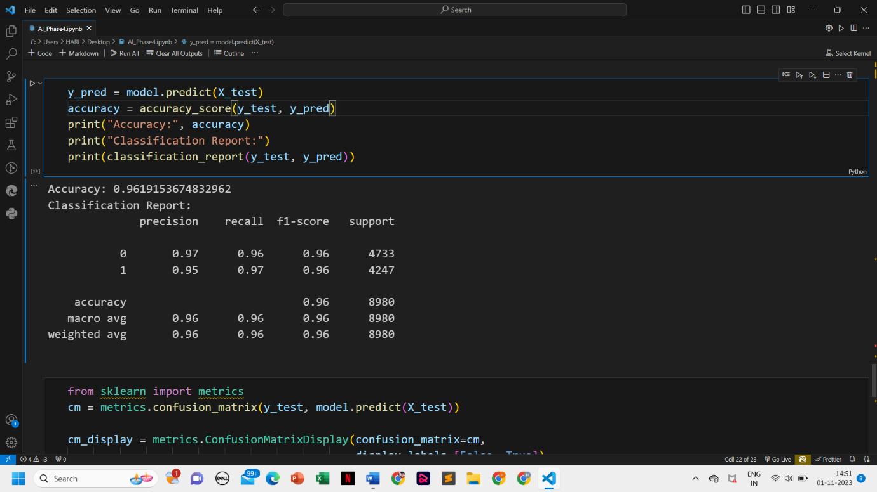

Plot matrix: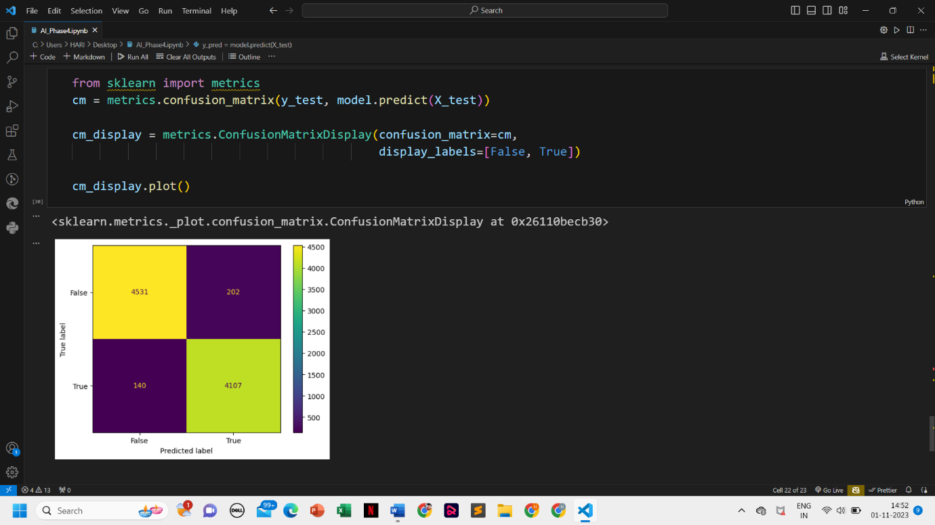

This is the over all phase 5 project that as successfully completed.